**Move-Out Cleaning Instruction**

**Please try your best to clean your apartment. You might ask: to what standard? If you are moving in, how clean would you like it?**

**The move-out rate for cleaning/repair will be $20/hour + material/parts.**

**Thank you for making it easy for everyone and your refund can be higher.**

**We appreciate your business and we have enjoyed having you!**

**Places people might overlook:**

1. Dust on the baseboards
2. Dust on the light fixture: take off the screw and clean glass
3. Dust on the blinds
4. Crumbs in the drawers
5. Top of the fridge
6. Bottom of the fridge and under -it rolls out easily
7. Behind and under oven –you can pull it out
8. Inside of the oven vent hood –take the grease filter out and clean it. It is above stove
9. The AC filter and hood –take the filter out and rinse the dust. This should have been cleaned bi-weekly
10. Soap scum of the bathtub and shower walls

**Things that are hard to clean and need special tools:**

1. The residue in the sink and in the toilet

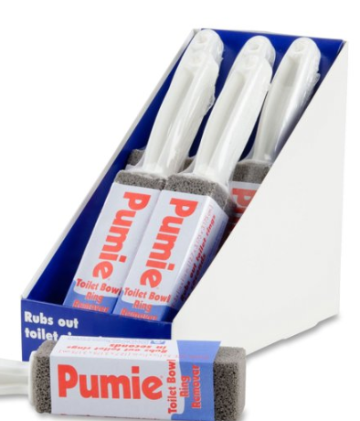 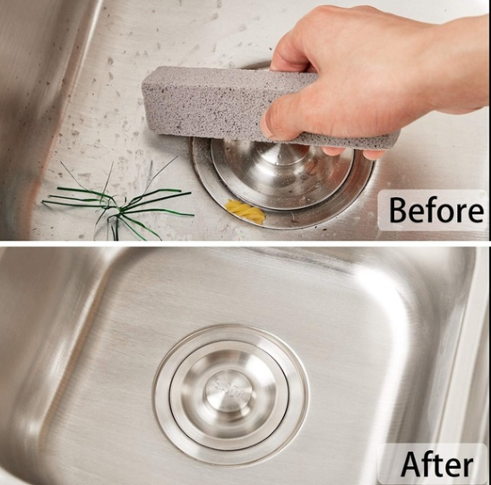

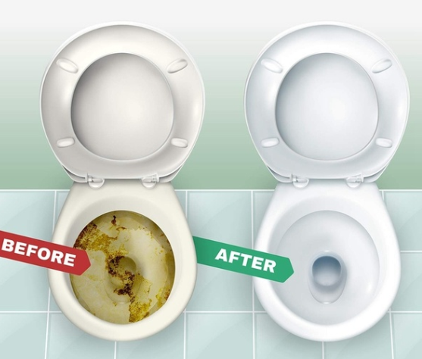

1. Oil residue on the vent hood: use any band of degreaser (**Goo Gone** is awesome) and a non-abrasive scrubber

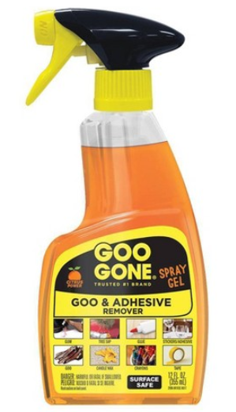

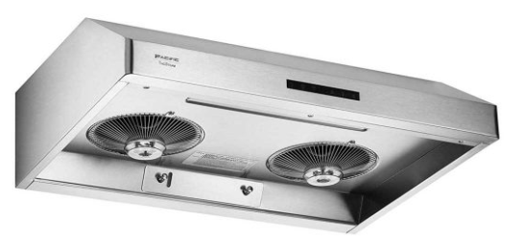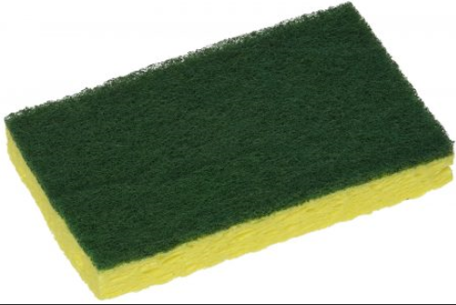

1. Yellow-ish porcelain sink and bathtub: use bleach powder and abrasive scrubber

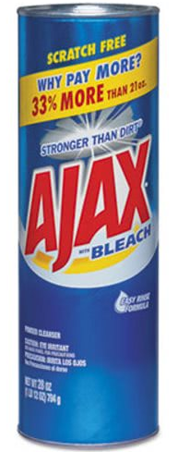 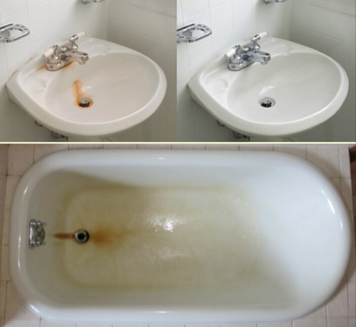

1. Spots on mirrors and glasses: use Windex with paper towel

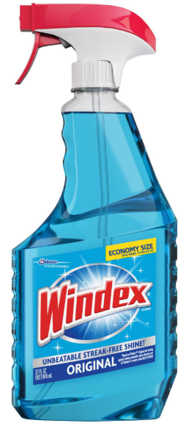 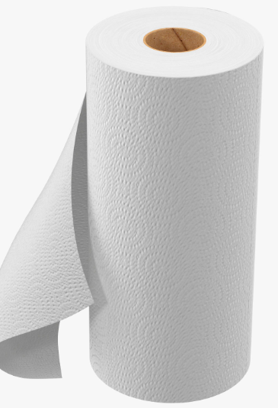

1. Residual on the glass-top oven: cleanser and scraper

